PROVISIONAL PATENT APPLICATION OF

Adrian Gropper MD, Watertown, MA;
Sean Doyle, Watertown, MA;
William L. Donner, Bronxville, NY;
Hugh V. Cottingham, Caldwell, NJ

FOR LETTERS PATENT OF THE UNITES STATES

SYSTEM AND METHOD FOR PATIENT CONTROLLED
COMMUNICATION OF DICOM PROTECTED HEALTH INFORMATION

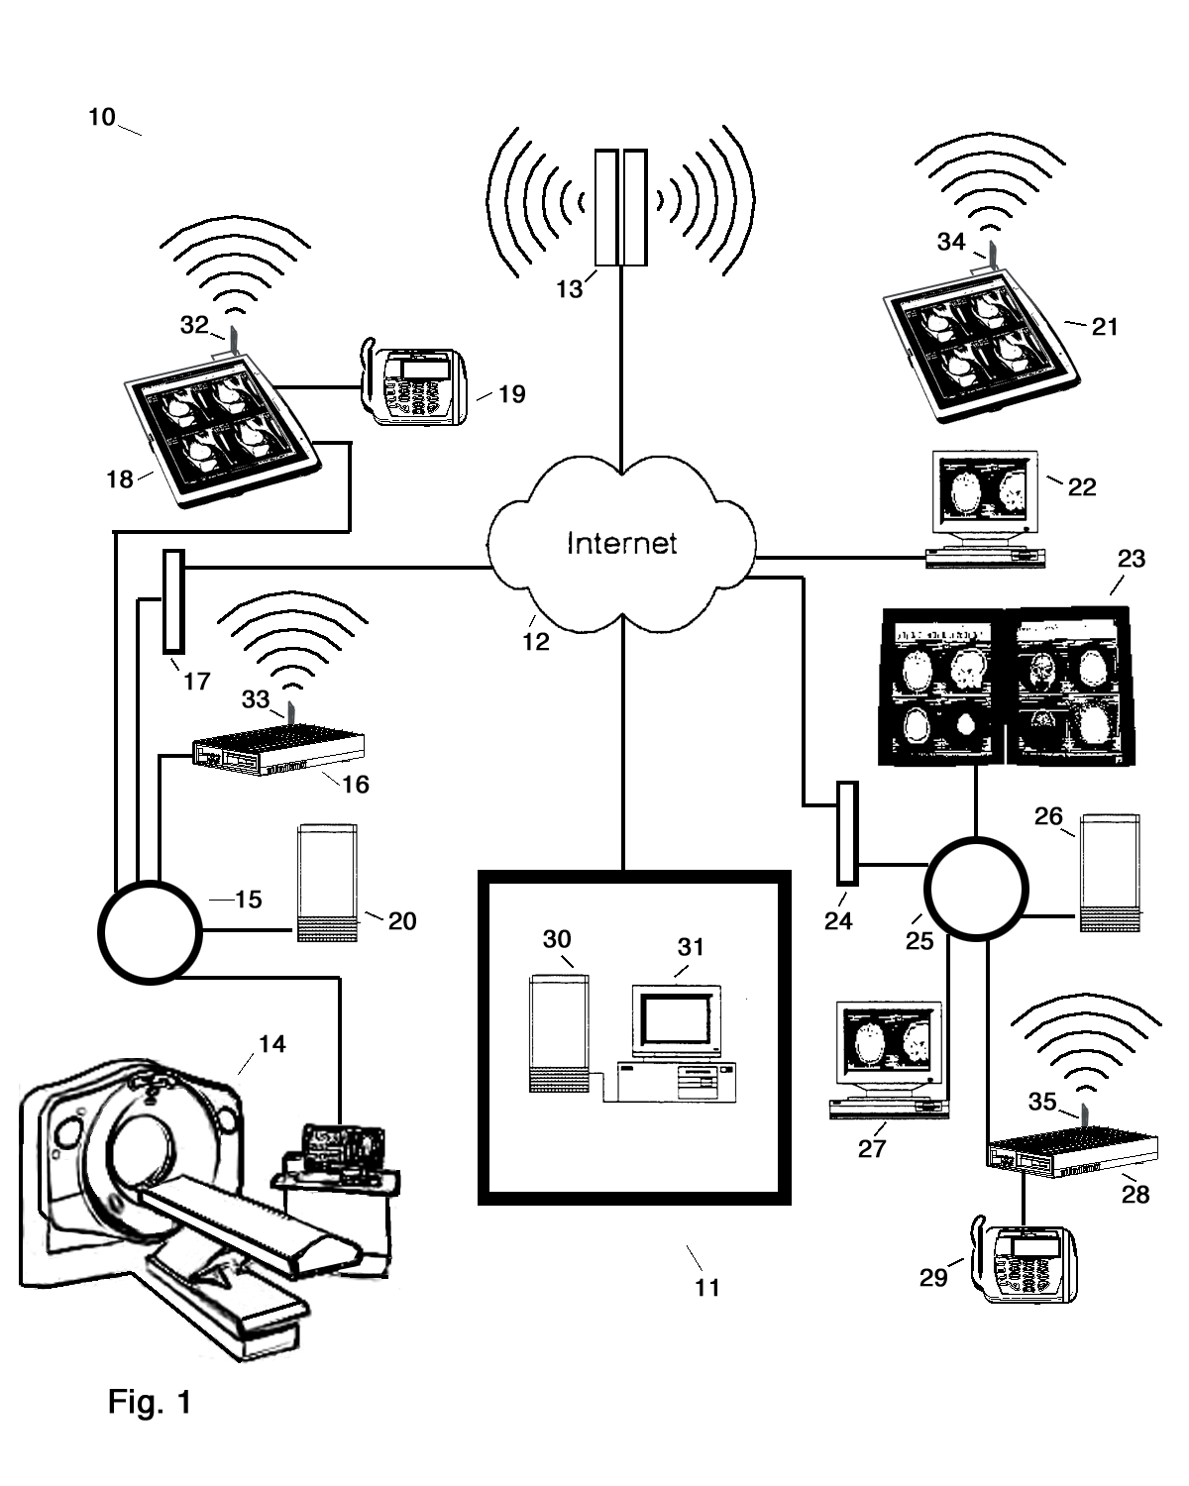
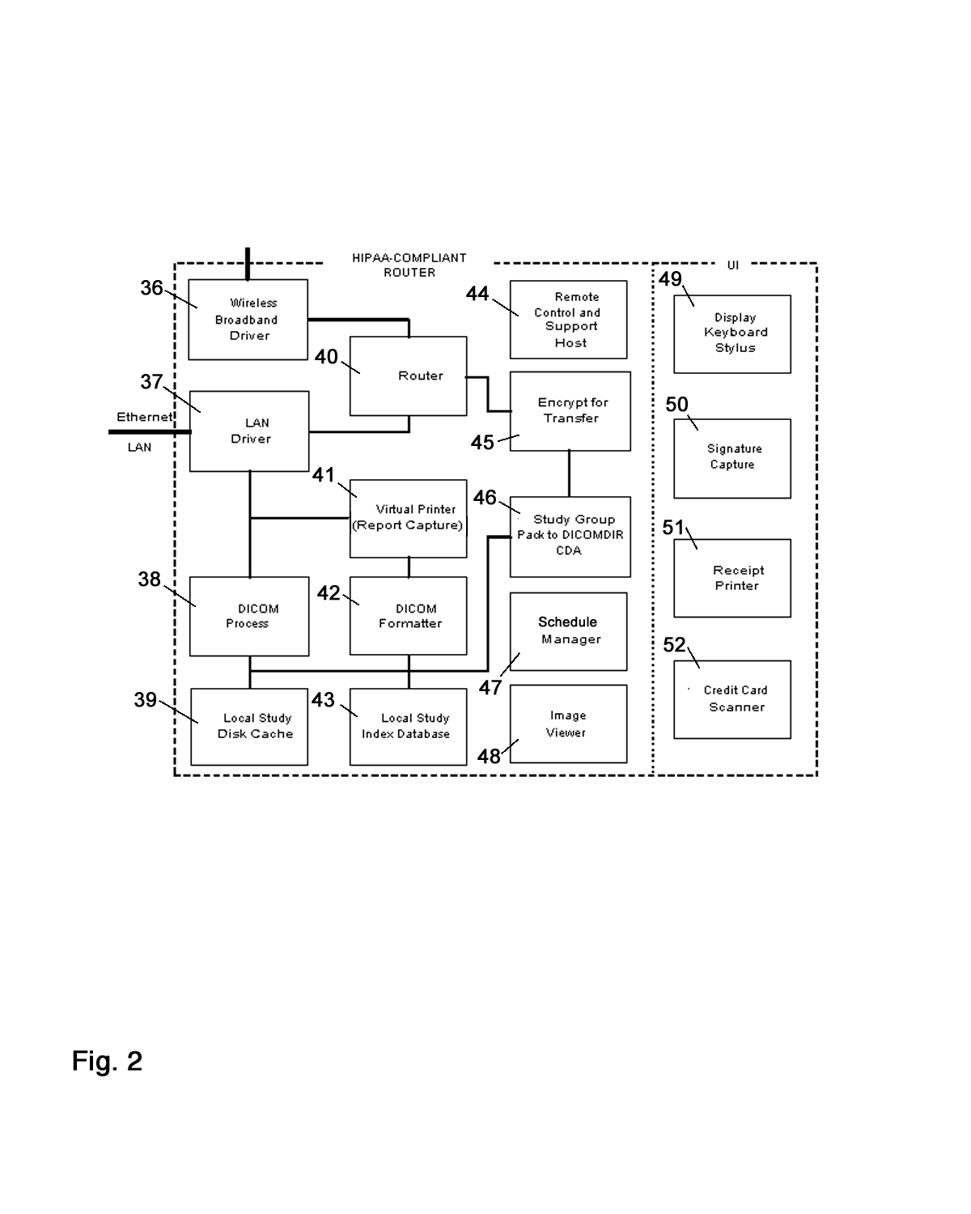
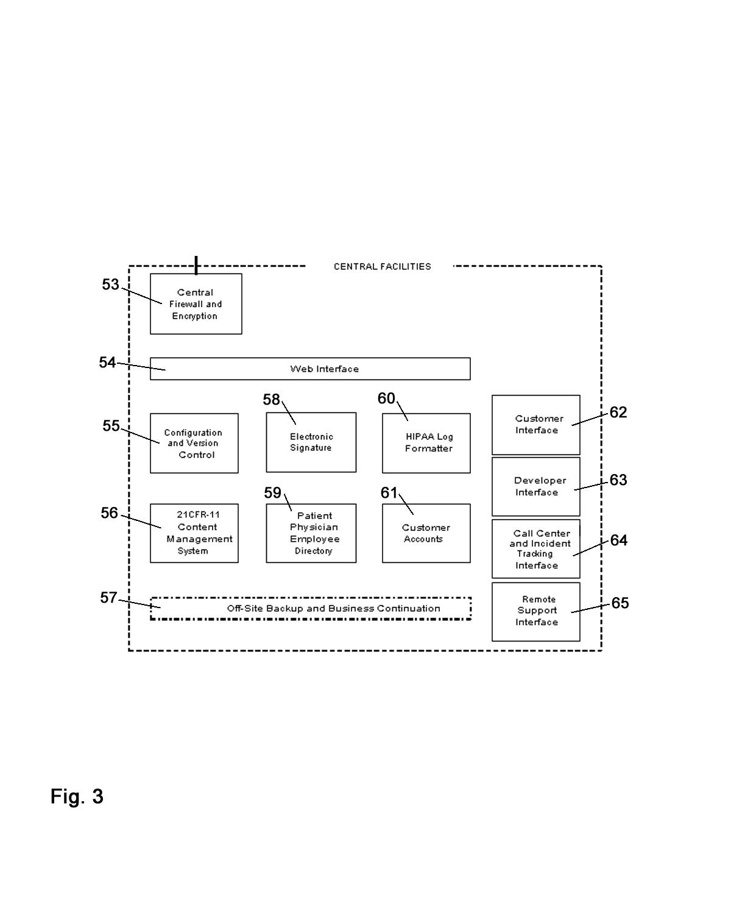
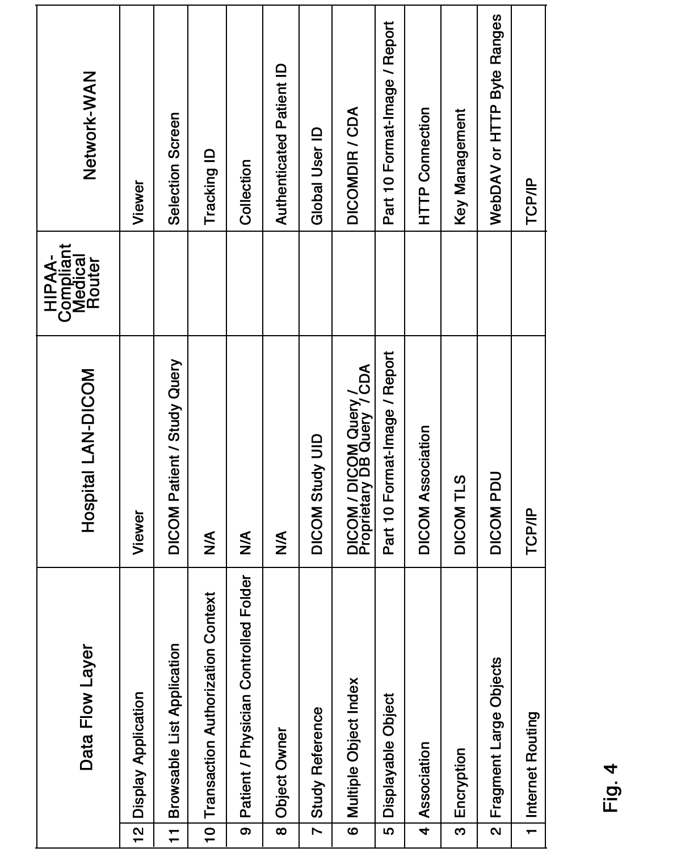
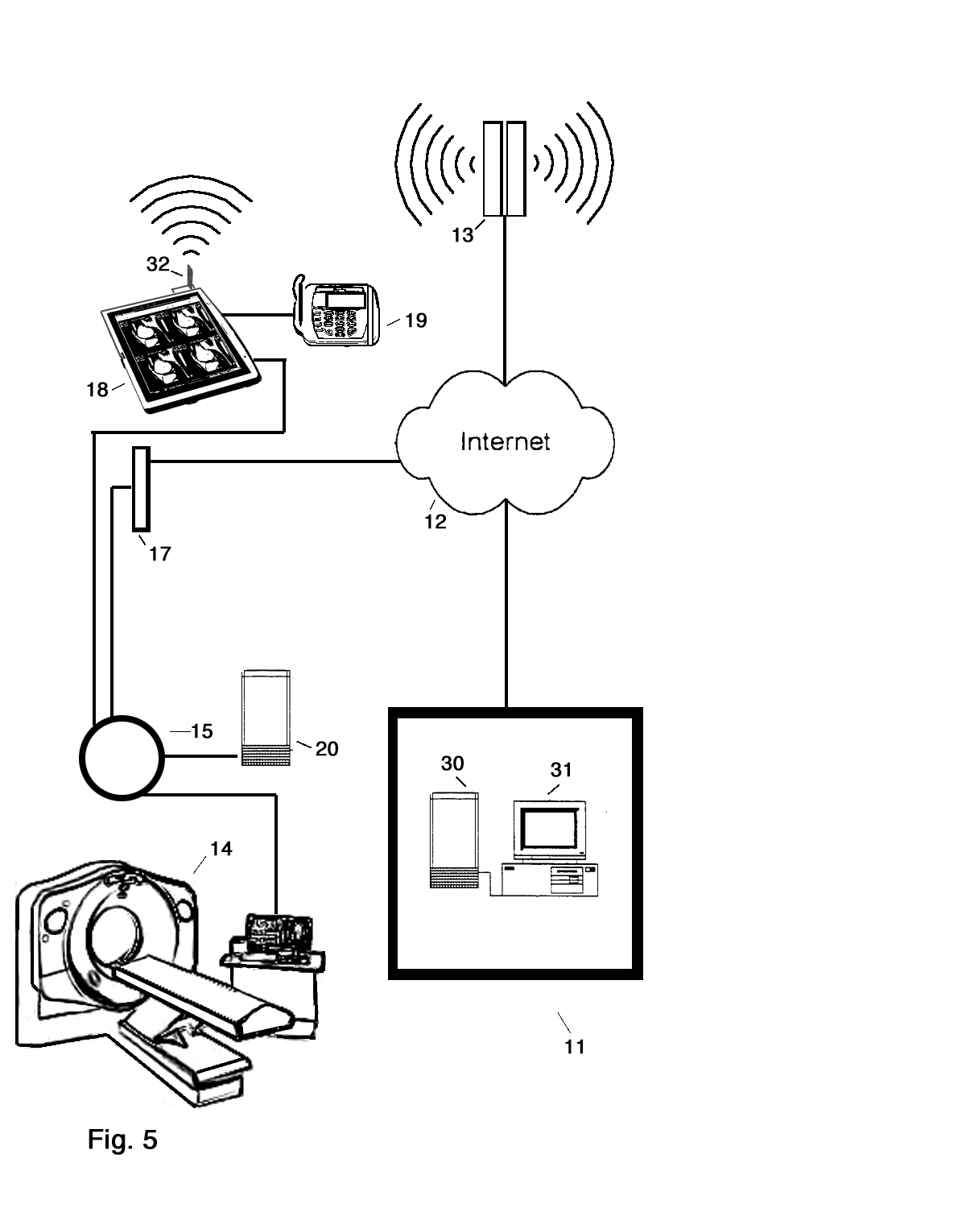
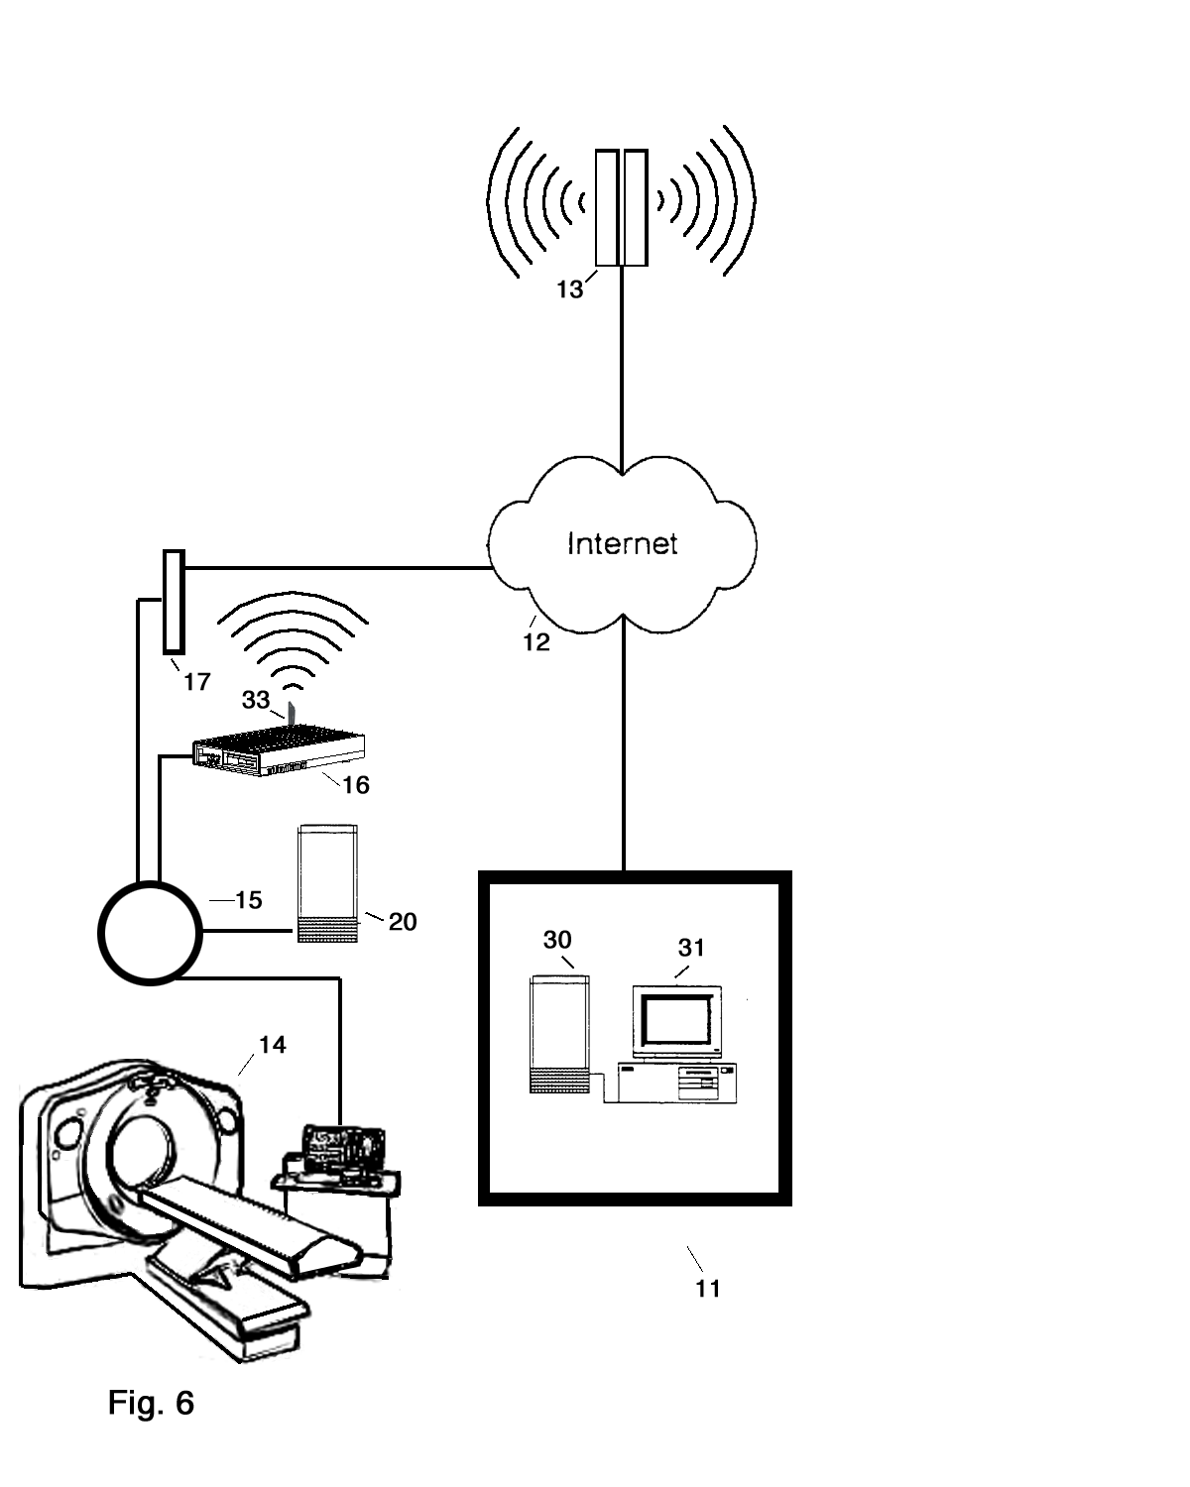
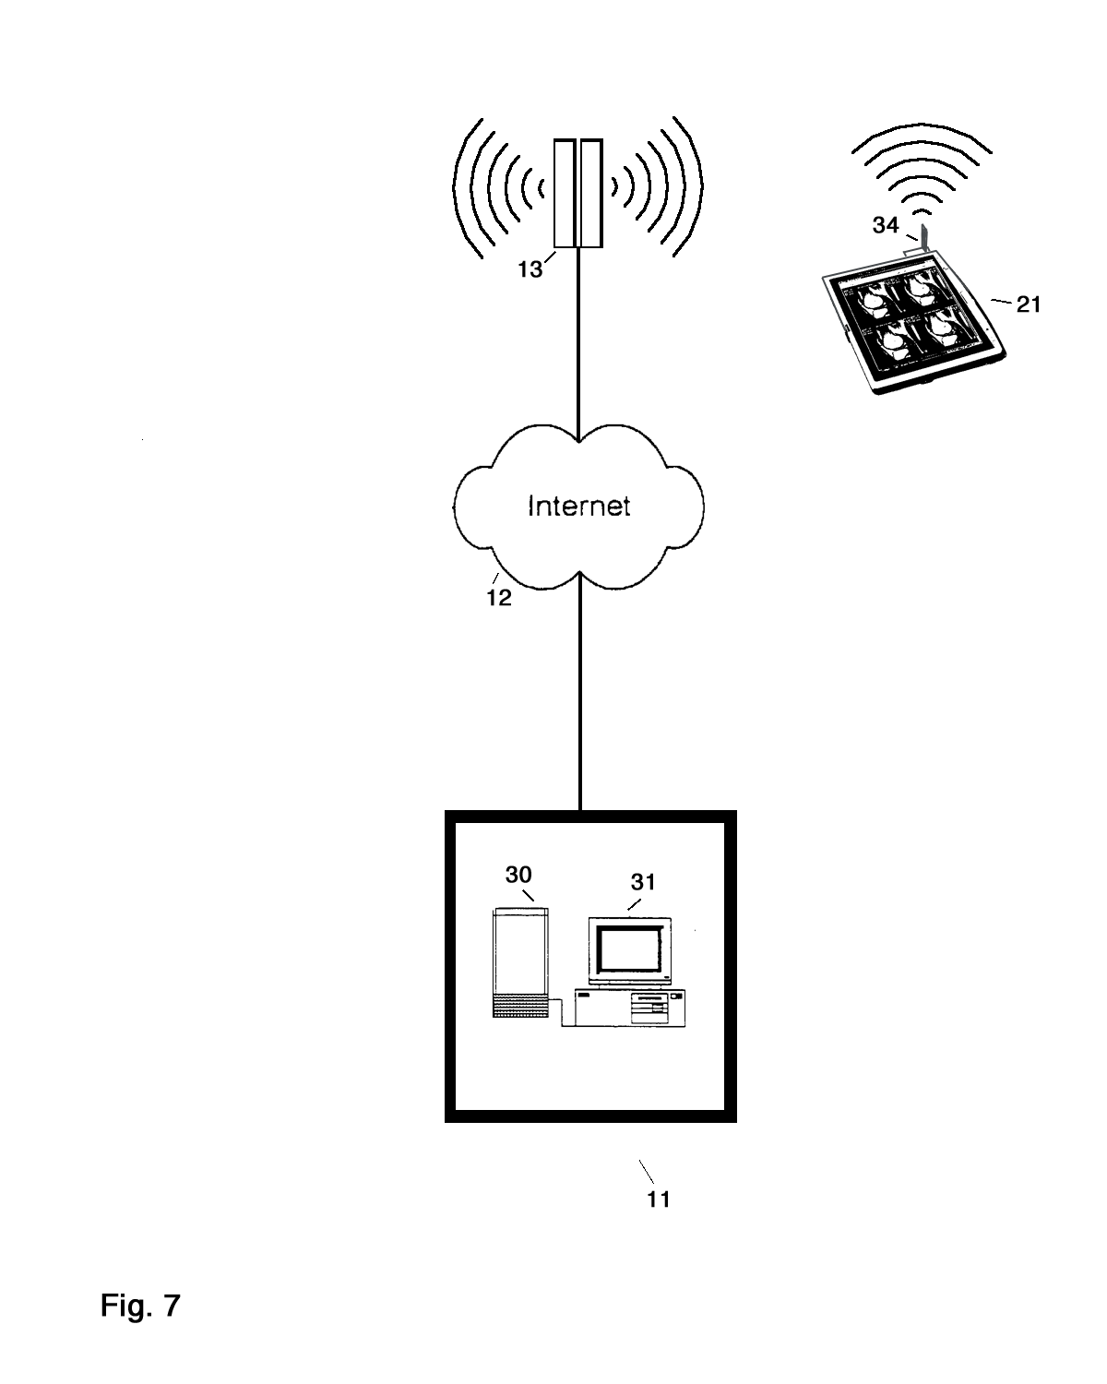
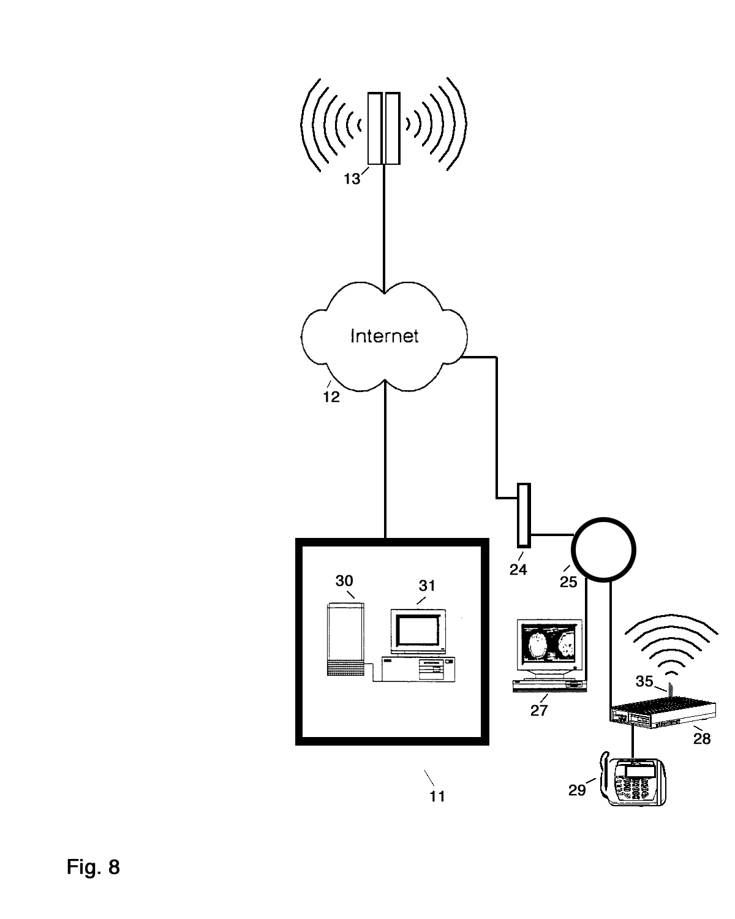
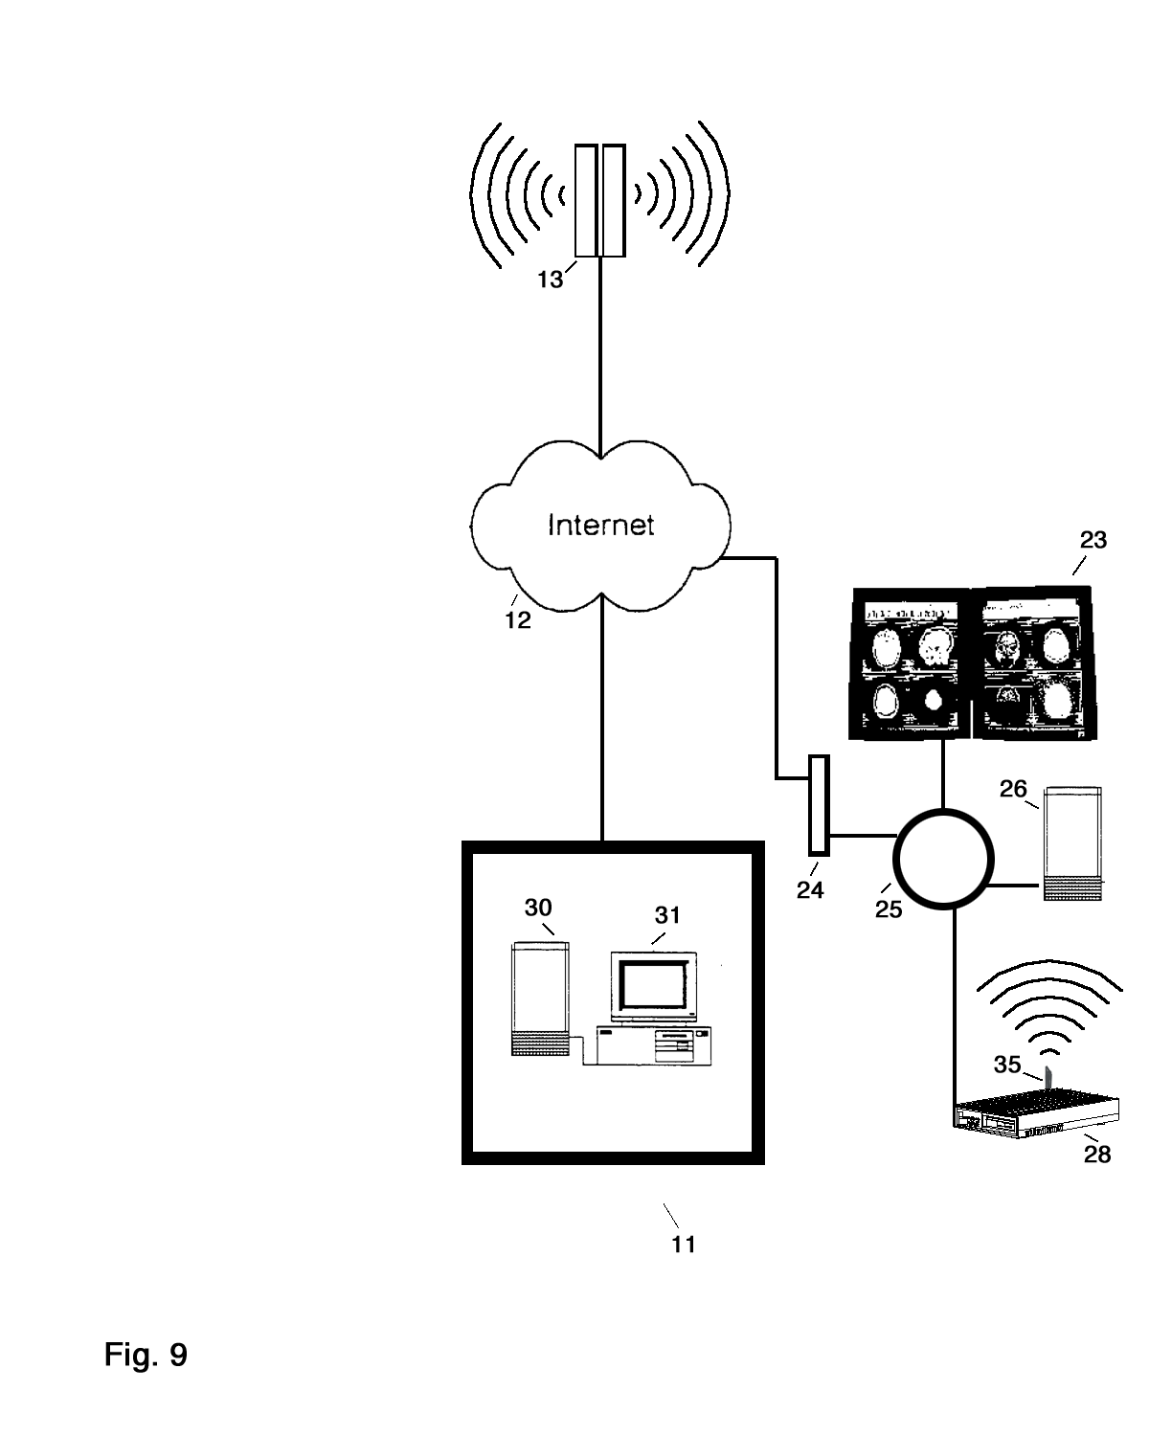
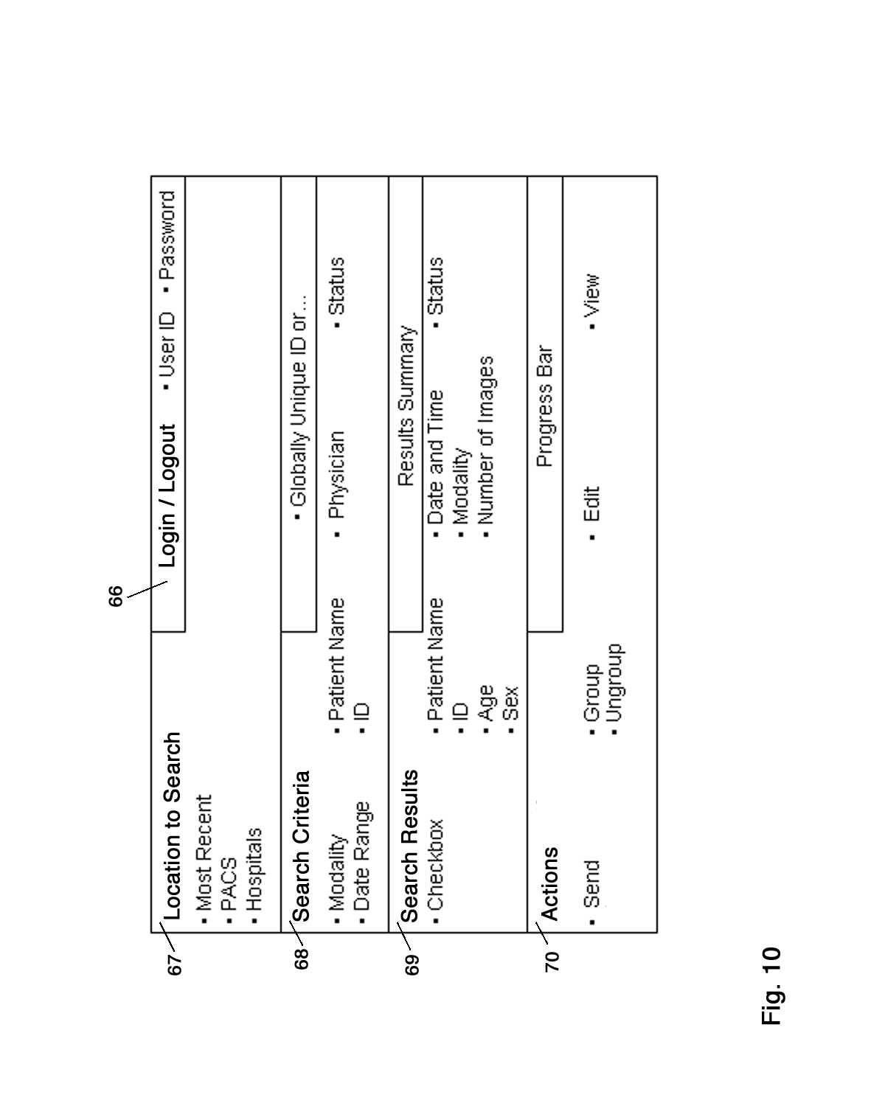
Background
- Medical imaging is an integral and growing part of modern healthcare. In the United States the annual number of imaging procedures exceeds 100 million. While the majority of these imaging procedures are film based, healthcare providers are moving to film-less systems. Picture Archiving and Communication Systems (PACS) which store images digitally are replacing film. Many diagnostic modalities such as CT and MR generate their images digitally and therefore are driving the need for (PACS). Additionally, there are numerous advantages to the management and archiving of medical images digitally.
- To facilitate interoperability between medical imaging and other instrumentation the Digital Imaging and Communications in Medicine (DICOM) standard was jointly developed by the American College of Radiology and the National Electrical Manufacturers Association for the communication of digital images and associated data. This greatly increased the utility of digital systems for storing and retrieving medical images.
- In 1996 legislation was passed known as the Health Insurance Portability and Accountability Act of 1996 (HIPAA). Although initially contemplated as a means to ensure that individuals could move their health insurance from one employer to another the legislation included many safeguards for the individuals regarding the privacy of their medical records and information.
- Although both the DICOM standard, which facilitated the communication of digital medical images, and (HIPAA), which mandated patient privacy, were both intended to benefit patients, the unintended consequence is that it is now much more difficult for a patient to obtain their own medical images. There are several reasons for this. Previous to (HIPAA) and digital systems, upon request, a patient would simply be handed their films by the physician or clerk (Provided that the films could be found. It is estimated that 30% of medical films are lost).

- Now, however, the patient has two problems. One, there is nothing to ‘give’ the patient in a digital system. The images are resident on some proprietary (PACS) and may be displayed but are not readily available off of the PACS system. In some instances the images can be copied to CD’s or other media but that form is not as convenient to view or as reliable to store. Two, HIPAA requires strict management of individually identifiable health information including keeping a record of access and only allowing access to authorized individuals. The combination of these two ‘problems’ result in patients legally having more control of their health information, but actually less access to their health information.

- While systems for storing and accessing digital medical images are well known in the art they are generally directed to institutional solutions to institutional problems.

- healthcare
- Brief Description of the Invention
- The invention, in one aspect, provides systems and methods relating to patient controlled communication of health information. According to one embodiment, the communication is between healthcare providers and patients. However, in alternative embodiments, the patient may control the communication of health information between any number parties. According to one feature, the communication is HIPAA compliant. According to another feature, the health information is communicated in accord with the DICOM standard. However, the systems and methods of the invention may employ any suitable information storage and communication protocols.
- In one configuration, the invention provides of a system including a HIPAA-compliant DICOM router for processing DICOM data using HIPAA based rules for the selection, assembly, transmission and/or display of logical entities of DICOM Protected hHealth Iinformation. According to one embodiment, the DICOM router is , is onnectd to the a local area network (LAN) of an imaging center of a hhcare provideThe imaging center may include any type of imaging mo example, without limitation, including such modalities as CT, MR, Ultrasound, etcand the like. The healthcare pr other source of DICOrotected hHealth iInformation. Preferably, Tthe HIPAA-complt DICOM router furtheruicates ver the same connection t thewith a wide area network (WA as the or Interncussed herein may be either wireless or wired can be madeough any suitable channel, including a cellular data connection. or communicates wirelessly through a broadband cellular data connection to the Internet card terminal, such as those known in the art. The credit terminal may include electronic signature capture and/or verification . A novel solution for patient authentication is provided through a credit card terminal
- According to one methodology, under the control and direction of an authenticated patient and in compliance with HIPAA regulations, the patient’s health information is communicated to a Trusted Intermediary central facility. Preferably, the Trusted Intermediary is also is HIPAA-compliant and maintains a HIPAA central registry log of instances of health information communication. The health information is stored under the control of the Trusted Intermediary central facility, which Trusted Intermediaryadministers the health information and operates as a Trust Service Provider to the patient. More particularly, the Trusted Service Provider responds to the patient’s requests to take any action regarding the patient’s health information. Such actions may include, without limitation, storing health information, deleting health information, and/or transferring health information in and/or out of the central facility from/to any patient authorized third party.
- Subsequently, as controlled and directed by the patient, the Trusted Intermediary central facility communicates the health information to a recipient healthcare provider or recipient patient.
- It is an object of this invention to provide a method for communication and management of health information .
- It is another object of this invention to provide a system for communication and management of health information under is patient controlled.
- It is yet another object of this invention to provide a HIPAA-compliant DICOM router network device.
- It is another object of this invention to provide a system for communication of DICOM Protected Health Information administered by a Trusted Intermediary central facility which operates as a HIPAA-compliant Trust Service Provider.
- It is another object of this invention to provide a method for communication of DICOM Protected Health Information administered by a Trusted Intermediary central facility which operates as a HIPAA-compliant Trust Service Provider.
- It is still another object of this invention to provide a HIPAA-compliant system for patient authentication, for example, using a credit card terminal with electronic signature capture and/or authentication.
- It is still another object of this invention to provide a HIPAA-compliant system for patient authentication using, for example, a tablet personal computer with electronic signature capture.
- It is a still a further object of this invention to provide a patient controlled, HIPAA-compliant system for communication of DICOM Protected Health Information from a healthcare provider to a Trusted Intermediary central facility.
- It is still another object of this invention to provide a patient controlled, HIPAA-compliant system for communication of DICOM Protected Health Information from a patient to a Trusted Intermediary central facility.
- It is a still a further object of this invention to provide a patient controlled, HIPAA-compliant system for communication of DICOM Protected Health Information from a Trusted Intermediary central facility to a healthcare provider.
- It is a still a further object of this invention to provide a patient controlled, HIPAA-compliant system for communication of DICOM Protected Health Information from a Trusted Intermediary central facility to a patient.
- It is yet a further object of this invention to provide a patient controlled, HIPAA-compliant system for communication of DICOM Protected Health Information that is wireless.

- It is another object of this invention to provide a HIPAA-compliant DICOM router which encrypts the communication of DICOM Protected Health Information.
- It is still another object of this invention to provide a patient controlled, HIPAA-compliant system for communication of DICOM Protected Health Information where a Trusted Intermediary central facility maintains a HIPAA central registry log of instances of communication of DICOM Protected Health Information.
Brief Description of the Drawings
- Fig. 1 shows various elements and implementations of a system according to an illustrative embodiment of the invention.
- Fig. 2 is a block diagram of illustrative functional elements of a HIPAA-compliant DICOM router embodiment of the system of Fig. 1.
- Fig. 3 is a block diagram of the an illustrative Trusted Intermediary central facility for the system of Fig. 1.
- Fig. 4 is a table showing exemplary dataflow on a Hospital LAN-DICOM and on a Network-WAN, as processed by a HIPAA-compliant DICOM router according to an illustrative embodiment of the invention.
- Fig. 5 shows an illustrative first capture configuration of the system of Fig. 1 used to communicate DICOM health information from a healthcare provider to the Trusted Intermediary central facility of Fig. 3, where the patient is authenticated locally at the healthcare provider using a credit card terminal with signature capture.
- Fig. 6 shows a second illustrative capture configuration of the system of Fig. 1 used to communicate DICOM health information from a healthcare provider to the Trusted Intermediary central facility of Fig. 3, where the patient is authenticated by the administrative control of the Trusted Intermediary central facility or by a referring physician.
- Fig. 7 shows a first illustrative access configuration of the system of Fig. 1 used to communicate, under the patient’s control, health information from the Trusted Intermediary central facility of Fig. 3 to a recipient healthcare provider such as a night radiologist.
- Fig. 8 shows a second illustrative access configuration of the system of Fig. 1 used to communicate, under the patient’s control, DICOM Protected Health Information from the Trusted Intermediary central facility of Fig. 3 to a recipient healthcare provider in a physician’s office.
- Fig. 9 shows a third illustrative access configuration of the system of Fig. 1 used to communicate, under the patient’s control, health information from the Trusted Intermediary central facility of Fig. 3 to a recipient, such as a computer aided diagnostics laboratory.
- Fig. 10 shows a diagram of an illustrative selection screen of an exemplary user interface for capture, access and administrative activity.

“individually identifiable health information” includes information that is a subset of health information, including demographic information collected from an individual, and; (1) Is created or received by a healthcare provider, health plan, employer, or healthcare clearinghouse; and (2) Relates to the past present, or future physical or mental health or condition of an individual; the provision of healthcare to an individual; or the past, present, or future payment for the provision of healthcare to an individual; and (i) That identifies the individual; or (ii) With respect to which there is a reasonable basis to believe the information can be used to identify the individual.
“Protected Health Information” includes individually identifiable health information that is: (1) Transmitted by electronic media; (2) Maintained in electronic media.
- “Electronic media” means: (1) Electronic storage media including memory devices in computers (hard drives) and any removable / transportable digital memory medium, such as magnetic tape or disk, optical disk, or digital memory card; or (2) Transmission media used to exchange information already in electronic storage media. Transmission media include, for example, the internet (wide-open), extranet (using internet technology to link a business with information accessible only to collaboration parties), leased lines, dial-up lines, private networks, and the physical movement of removable / transportable electronic storage media.
- “healthcare provider” includes providers of medical or health services, and any other person or organization who furnishes, bills, or is paid for healthcare in the normal course of business.
- Trusted Intermediary means an entity for communication and storage of health information. Preferably, the Trusted Intermediary is HIPPA compliant and operates as a Trust Service Provider.
- “Trust Service Provider” means an entity that provides services to authenticated patients, and/or other authenticated parties, relating to storage and transfer of health information.
- “HIPAA central registry log” means a file on electronic media relating to each instance of communication of Protected Health Information containing the information necessary to maintain HIPAA compliance.
- “Authentication” means the corroboration that a person is who he/she is claiming to be.

- “HIPAA” means the combined regulations of the Health Insurance Portability and Accountability Act of 1996.

- “HIPAA-compliant DICOM router” means a networking device which processes DICOM data using HIPAA based rules for the selection, assembly, transmission or display of logical entities of Protected Health Information.
- “DICOM” means the Digital Imaging and Communications in Medicine standard jointly developed by the American College of Radiology and the National Electrical Manufacturers Association for the communication of digital images and associated data.
- “DICOM LAN” means a local area network utilizing the DICOM standard.
- “PACS” means Picture Archiving and Communication Systems.

- The invention, in one illustrative embodiment, is directed to patient centric systems and methods for the communication and management of health information. According to one feature, an authenticated patient can direct transfer of health information to and from a Trusted Intermediary central facility. By way of example, an authenticated patient may direct the transfer of his/her health information, including individually identifiable health information from any third party to the Trusted Intermediary central facility and from the Trusted Intermediary to any third party. According to one embodiment, the patient pays a subscription, storage, and/or transaction fee for obtaining this service from the Trusted Intermediary.
- Although the below illustrative embodiments are discussed in terms of HIPPA compliance and DICOM formatted information. Neither of these features are necessary to the invention and are only used for illustrative purposes. Additionally, the patient, Trusted Intermediary, healthcare providers and any other third parties may communicate with each other via any suitable modality, included wired and wireless communication modalities. Additionally, these parties may communicate via any suitable client device, such as a desk top, laptop, tablet or handheld computer, including wireless telephones and personal digital assistants. Also, although the illustrative embodiment is described in terms of credit card like identification, the identification of a patient may be verified in any suitable manner. Further, although the below illustrative embodiment is described in terms of Protected Health Information, the systems and methods of the invention may be employed for any information, including any information relating to the health of a person.
- In one illustrative embodiment, from an implementation point of view, the system generally has two basic actions: (1) providing HIPAA-compliant capture, under patient control, of DICOM Protected Health Information into the system and (2) providing HIPAA-compliant access, under patient control, to the DICOM Protected Health Information in the system. According to one illustrative embodiment, a HIPAA-compliant DICOM router provides this functionality in combination with other system elements described below. Preferably, the HIPAA-compliant DICOM router is configured and implemented in numerous ways to accommodate differing clinical environments of capture and access.
- Fig. 1 depicts a conceptual block diagram for a user centric system for transferring and managing health information according to an illustrative embodiment of the invention. As shown in Fig. 1, Capture of DICOM Protected Health Information into the system generally occurs at a healthcare provider such as an imaging center or physician’s office and preferably involves the communication, under patient control, of the DICOM Protected Health Information to the Trusted Intermediary central facility 11. Capture and communication, under patient control, of DICOM Protected Health Information from a patient’s computer. is also possible.
- Access to DICOM Protected Health Information preferably involves the communication, under patient control, of the DICOM Protected Health Information from the Trusted Intermediary central facility 11 to a recipient healthcare provider or recipient patient.
- The implementation of the system and the HIPAA-compliant DICOM router has numerous possible configurations. Referring to Fig. 1 HIPAA-compliant DICOM routers 16 and 18 represent examples of capture configurations. HIPAA compliant DICOM routers 21 and 28 represent examples of access configurations. Common to the various illustrative configurations is the Trusted Intermediary central facility 11. The illustrative Trusted Intermediary includes electronic media 30 for storage and transmission of DICOM Protected Health Information and administrative control 31. Internet connection 12 and wireless broadband Internet Service Provider 13 are common elements to of various configurations of the system and a personal computer 22 connected to Internet 12 may optionally be included as an element of various configurations as desired.
- The illustrative HIPAA-compliant DICOM router includes the following functional blocks (Fig. 2). Wireless Broadband Driver 36 supports a bi-directional Internet connection over the wireless network (for example Verizon 1XRTT or equivalent). LAN Driver 37 is an optional connection to the LAN used to access a modality, a PACS or to support a 3D workstation. DICOM process 38 implements support for DICOM communications between modalities, PACS, and workstation devices. Local Study Disk Cache 39 is a short-term store for study components as they are being assembled for transport to the central facility 11 or to accelerate delivery to a local workstation 23. Router 40 calculates the least cost path between the HIPAA-compliant DICOM router and the Trusted Intermediary central facility 11. Virtual Printer 41 captures patient medical records by appearing as a network printer to electronic medical records software. DICOM formatter 42 collects related pages of captured DICOM records into a study-like DICOM object and adds the required header information. Local Study Index Database 43 Tracks and organizes objects in the Local Study Disk Cache 39 and Preserves the integrity of HIPAA-compliant DICOM router transactions. Remote Control and Support Host 44 enables secure log-on, screen sharing, software installation and update over both the WAN and the Internet and encrypts, authorizes and logs all activity involving DICOM Protected Health Information. Encrypt for Transfer 45 encrypts, authorizes and logs all activity involving DICOM Protected Health Information. Study group 46 packages multiple study, report and other objects into a collection relevant to the patient and physician. Schedule Manager 47 manages the DICOM process 38 by updating the Local Study Index Database 43. Image viewer 48 supports display of images and reports. Display, Keyboard, Stylus 49 is the local user interface. Signature capture 50 captures signatures and stores signatures at the Trusted Intermediary central facility 11. Receipt printer 51 prints a description of the DICOM Protected Health Information transaction. Credit card scanner 52 (credit card terminal) is used to identify a patient.
- The illustrative Trusted Intermediary central facility 11 includes electronic media 30 for the storage and transmission of the DICOM Protected Health Information and administrative control 31. The administrative control 31 is composed of the following functional blocks as shown in Fig. 3. Central Firewall and Encryption 53 secures all wired and wireless object and support communications of DICOM Protected Health Information. Web Interface 54 provides secure communications. Configuration and Version Control 55 tracks the software installed and configuration parameters. 21CFR-11 Content Management System 56 secures DICOM Protected Health Information, audit and log information as well as FDA documentation. Off-Site Backup and Business Continuation 57 mirrors all aspects of the Trusted Intermediary central facility 11 to meet 21CFR-11 and business continuation requirements. Electronic signature 58 enables non-reputable user authentication and authorization. Patient, Physician, Employee Directory 59 is a central authority with delegation features. HIPAA log Formatter 60 assembles information into legally-mandated Protected Health Information transactions for presentation the patient. Customer Accounts 61 Individual configuration and account management pages for physicians and patients. Customer Interface 62 authenticates patients and physicians while restricting access to authorized information. Developer interface 63 enables the installation and configuration of software that supports regulatory requirements. Call Center and Incident Tracking Interface 64 enables authorized central facility personnel to perform additional functions. Remote Support Interface 65 enables support in accordance with HIPAA regulations.
- The bridging by the HIPAA-compliant DICOM router between institutional control (Hospital LAN-DICOM) and patient control (Network-WAN) is depicted in the data flow table of Fig. 4. The table shows the data flow on the Hospital LAN-DICOM and on Network-WAN as processed by the HIPAA-compliant DICOM router.
- Access to the information on the Hospital LAN typically may be controlled on an institutional basis but is otherwise uncontrolled once access is gained to the Hospital LAN. Privacy of individually identifiable health information is not contemplated on the Hospital LAN.
- Alternatively, the HIPAA-compliant DICOM router only communicates such individually identifiable health information that is authorized, as controlled by an authenticated patient. As shown in the diagram of the system selection screen (Fig. 10) a user of the system must login 66 with User ID and Password to gain access to the system. The Transaction Authorization Context Tracking ID (layer 10) Fig. 4 functions with the login Screen 66 (Fig 10) to establish an authorization context. The authorization context may be limited to the patient; to clinical personnel such as technologists, physicians and nurses; to the patient’s physician; to a business associate of the healthcare provider such as a Computer Aided Diagnosis 3D laboratory; etc. Subsequently, Location to Search 67 and Search Criteria 68 yield Search Results 69. In all instances, which items are viewable in the selection screen (Fig 10) Search Results 69 list depend on the authorization context. Consequently, the Actions 70, such as display via Image Viewer 48 (Fig. 2), that can be preformed are controlled by the authorization context and limited to the items on the Search Results 69 list. The HIPAA-compliant DICOM router further supports the HIPAA concept that individually identifiable health information is owned by the patient through the use of an Authenticated Patient ID (Object Owner layer 8) and supports other HIPAA requirements including Encryption (layer 3) Fig. 4 of the individually identifiable health information.
- Fig. 5 depicts a first capture configuration. A tablet computer implementation of the HIPAA-compliant DICOM router 18 is connected to the DICOM LAN 15 of a healthcare provider imaging center which has imaging modality 14 and PACS 20 further connected to the DICOM LAN 15. The DICOM LAN 15 is connected to the Internet 12 through firewall 17. The tablet computer implementation of the HIPAA-compliant DICOM router 18 also has a wireless broadband Internet connection 32 and is also connected to credit card terminal with signature capture 19. Wireless broadband Internet connection 32 communicates with wireless broadband Internet Service Provider 13. The user interface 49, 50, 51, 52 (Fig. 2) is accessible through the tablet computer display to a clerk that services patient requests regarding their Protected Health Information.
- In use a patient is authenticated through the credit card terminal with signature capture 19 and the patient’s DICOM Protected Health Information is communicated, under the provider’s and patient’s direction, from either imaging modality 14 or PACS 20 to DICOM LAN 15 to tablet COMPUTER implementation of the HIPAA-compliant DICOM router 18 where it is processed as depicted in block diagram Fig 2 and data flow table Fig 4. and then communicated either through firewall 17 to Internet 12 to the Trusted Intermediary central facility 11 where it is stored using electronic media 30 under Administrative control 31 or through wireless broadband Internet connection 32 to wireless broadband Internet Service Provider 13 to Internet 12 to Trusted Intermediary central facility 11 where it is stored using electronic media 30 under Administrative control 31.
- A second capture configuration is depicted in Fig. 6. A patient computer implementation of the HIPAA-compliant DICOM router with no local display 16 is connected to the DICOM LAN 15 of a healthcare provider imaging center which has imaging modality 14 and PACS 20 further connected to the DICOM LAN 15. The DICOM LAN 15 is connected to the Internet 12 through firewall 17. The patient computer implementation of the HIPAA-compliant DICOM router with no local display 16 has a wireless broadband Internet connection 33 which communicates with wireless broadband Internet Service Provider 13. The patient computer implementation of the HIPAA-compliant DICOM router with no local display 16 is managed remotely through administrative control 31 of the Trusted Intermediary central facility 11.
- In use, patient authentication is illustratively performed through administrative control 31 of the Trusted Intermediary central facility 11 or previously through a referring physician and the patient’s DICOM Protected Health Information is communicated, under the patient’s direction as administered by administrative control 31, from either imaging modality 14 or PACS 20 to DICOM LAN 15 to patient computer implementation of the HIPAA-compliant DICOM router with no local display 16 where it is processed as depicted in block diagram Fig 2 and data flow table Fig 4. and then routed either through firewall 17 to Internet 12 to the Trusted Intermediary central facility 11 where it is stored using electronic media 30 under administrative control 31 or through wireless broadband Internet connection 33 to wireless broadband Internet Service Provider 13 to Internet 12 to Trusted Intermediary central facility 11 where it is stored using electronic media 30 under administrative control 31.
- Fig. 7 depicts a first illustrative access configuration. In this configuration, a tablet computer implementation of the HIPAA-compliant DICOM router 21 is connected only through the wireless broadband connection 34 to wireless Internet Service Provider 13 to Internet 12.
- In use, authentication is performed with the user interface and tablet display and or centrally through administrative control 31 of the Trusted Intermediary central facility 11 and the patient’s DICOM Protected Health Information is communicated, under the patient’s direction as administered by administrative control 31, using electronic media 30 from the Trusted Intermediary central facility 11 to the Internet 12 to wireless broadband Internet Service Provider 13 to wireless broadband connection 34 of the tablet implementation of the HIPAA-compliant DICOM router 21 where it is processed as depicted in block diagram Fig 2 and data flow table Fig 4.A second illustrative access configuration is depicted in Fig. 8. In this configuration the patient computer implementation of the HIPAA-compliant DICOM router with no local display 28 is connected to a LAN 25, connected through wireless broadband connection 35 to wireless Internet Service Provider 13 and connected to credit card terminal with signature capture 29.
- In an illustrative use in a Physicians office, a patient is authenticated through the use of the credit card terminal with signature capture 29 and the user interface of the patient computer implementation of the HIPAA-compliant DICOM router with no local display 28 which is accessible to office personnel on desktop computer 27 connected to the LAN 25 and the patient’s DICOM Protected Health Information is communicated, under the patient’s direction, using electronic media 30, under administrative control 31, from the Trusted Intermediary central facility 11 to the Internet 12 to either wireless broadband Internet Service Provider 13 to wireless broadband connection 35 to the patient computer implementation of the HIPAA-compliant DICOM router with no local display 28 where it is processed as depicted in block diagram Fig 2 and data flow table Fig 4. and displayed on desktop computer 27 or to firewall 24 to LAN 25 to the HIPAA-compliant DICOM router with no display 28 where it is processed as depicted in block diagram Fig 2 and data flow table Fig 4. and displayed on desktop computer 27.
- A third illustrative access configuration is depicted in fig. 9. In this configuration the patient computer implementation of the HIPAA-compliant DICOM router with no local display 28 is connected to LAN 25, to which is also connected a DICOM workstation 23 and a PACS 26, and is connected through wireless broadband connection 35 to wireless broadband Internet Service Provider 13.
- In an illustrative use in a Computer Aided Diagnostics Laboratory, authentication is performed centrally through administrative control 31 of the Trusted Intermediary central facility 11 and the patient’s DICOM Protected Health Information is communicated, under the patient’s direction as administered by administrative control 31, using electronic media 30, from the Trusted Intermediary central facility 11 to the Internet 12 to either firewall 24 to LAN 25 to a patient computer implementation of the HIPAA-compliant DICOM router with no local display 28 where it is processed as depicted in block diagram Fig 2 and data flow table Fig 4. and then to LAN 25 and to DICOM workstation 23 or to wireless broadband Internet Service Provider 13 to wireless broadband connection 35 to the patient implementation of the HIPAA-compliant DICOM router with no local display 28 where it is processed as depicted in block diagram Fig 2 and data flow table Fig 4. and then to LAN 25 and to DICOM workstation 23.
- Numerous other access and capture configurations may be configured as desired and may be customized with substitution of various elements. For instance, patient computer 22 may be used in either capture or access as a substitute for such elements and functions that can be administered centrally by administrative control 31using a wired connection.
- Common to the illustrative systems and methods including the capture and access configurations is the Trusted Intermediary central facility 11 which establishes, maintains and administers, under administrative control 31, a HIPAA central registry log (Fig. 3 HIPAA log Formatter 60) of every instance of communication of DICOM Protected Health Information to maintain HIPAA compliance. The Trusted Intermediary central facility further operates as a Trust Service Provider by encrypting all communication of instances of Protected Health Information to provide and maintain HIPAA compliance for patients and healthcare providers.
- Also common to the illustrative systems and methods including substantially all capture and access configurations is the use of a credit card terminal with signature capture 19, 29 (Fig. 1) to electronically authenticate the patient.
- Although patient authentication is well known in the art it is most often paper based. By including a credit card terminal with signature capture with the system, a patient can be authenticated with two instances of authentication, the patient signature and or the credit card number, and both instances can be linked and electronically stored for HIPAA compliance. Further, in subsequent transactions, the patient may conveniently utilize a single linked instance, such as the credit card number, as authentication.
- It will thus be seen that the objects set forth above, among those made apparent from the preceding description, are efficiently attained and, since certain changes may be made in the above construction without departing from the spirit and scope of the invention, it is intended that all matter contained in the above description or shown in the accompanying drawings shall be interpreted as illustrative and not in a limiting sense.
- It is also to be understood that the following claims are intended to cover all of the generic and specific features of the invention herein described and all statements of the scope of the invention which, as a matter of language, might be said to fall therebetween.

We claim:
- A system for patient controlled communication of DICOM Protected Health Information comprising, in combination, HIPAA-compliant DICOM router for processing and communication of DICOM Protected Health Information, Trusted Intermediary central facility for communication, storage and administration of DICOM Protected Health Information processed by said HIPAA-compliant DICOM router and patient authentication element cooperating with said HIPAA-compliant DICOM router and Trusted Intermediary central facility for enabling patient controlled communication of said processed DICOM Protected Health Information.

- A system for patient controlled communication of DICOM Protected Health Information as claimed in claim 1, wherein said HIPAA-compliant DICOM router includes a disk cache, for accelerating said communication.

- A system for patient controlled communication of DICOM Protected Health Information as claimed in claim 2, wherein said processing by HIPAA-compliant DICOM router includes encryption of said DICOM Protected Health Information.

- A system for patient controlled communication of DICOM Protected Health Information as claimed in claim 3, wherein said Trusted Intermediary central facility includes encryption key management.

- A system for patient controlled communication of DICOM Protected Health Information as claimed in claim 3, and including a wireless broadband connection for connecting said HIPAA-compliant DICOM router to the Internet wirelessly.

- A system for patient controlled communication of DICOM Protected Health Information as claimed in claim 3, and including credit card terminal for patient authentication.

- A system for patient controlled communication of DICOM Protected Health Information as claimed in claim 6, wherein said credit card terminal includes electronic signature capture.

- A system for patient controlled communication of DICOM Protected Health Information as claimed in claim 1, and including HIPAA central registry log for logging instances of communication of DICOM Protected Health Information.

- A system for patient controlled communication of DICOM Protected Health Information as claimed in claim 1, wherein said Trusted Intermediary central facility administratively controls electronic media for communication and storage of said DICOM Protected Health Information processed by said HIPAA-compliant DICOM router.

- A system for patient controlled communication of DICOM Protected Health Information as claimed in claim 5, wherein said HIPAA-compliant DICOM router is implemented using a tablet patient computer.

- A system for patient controlled communication of DICOM Protected Health Information as claimed in claim 10, wherein said tablet patient computer includes electronic signature capture.

- A method for patient controlled communication of DICOM Protected Health Information, the method comprising the steps of:

  - communicating DICOM Protected Health Information using electronic media, under the direction of an authenticated patient and under at least one or more of the rules and regulations of HIPAA, from a healthcare provider or patient source of DICOM Protected Health Information to a Trusted Intermediary central facility;

  - storing the DICOM Protected Health Information, communicated from the healthcare provider or patient source under an authenticated patient’s direction, using electronic media under the administrative control of the Trusted Intermediary central facility;

  - creating and maintaining a HIPAA central registry log using electronic media under the administrative control of the Trusted Intermediary central facility and logging, under at least one or more of the rules and regulations of HIPAA, the instance of the communication of the DICOM Protected Health Information from the healthcare provider or patient source to the Trusted Intermediary central facility;

  - communicating DICOM Protected Health Information using electronic media, under the direction of an authenticated patient and under at least one or more of the rules and regulations of HIPAA, from electronic media under the administrative control of the Trusted Intermediary central facility to a recipient healthcare provider or recipient patient; and

  - logging the instance of the communication of the DICOM Protected Health Information, under at least one or more of the rules and regulations of HIPAA, from the electronic media under the administrative control of the Trusted Intermediary central facility to a recipient healthcare provider or recipient patient.

- A method for patient controlled communication of DICOM Protected Health Information as recited in claim 12, wherein a credit card terminal with signature capture is available for patient authentication, said step (a) further comprises the step of:
authenticating the patient by capturing the patients signature and or credit card information electronically, using a credit card terminal with electronic signature capture capability.

- A method for patient controlled communication of DICOM Protected Health Information as recited in claim 12, wherein a tablet patient computer with signature capture capability is available for patient authentication, said step (a) further comprises the step of:

authenticating the patient by capturing the patients signature and or credit card information electronically, using a tablet patient computer with electronic signature capture capability.

- A method for patient controlled communication of DICOM Protected Health Information as recited in claim 12, wherein a patient computer is available for patient authentication, said step (a) further comprises the step of:

authenticating the patient by capturing the patients credit card information electronically, using a patient computer.

- A method for patient controlled communication of DICOM Protected Health Information as recited in claim 12, wherein electronic media includes a wireless broadband connection for communication, said step (a) further comprises the step of:

communicating DICOM Protected Health Information wirelessly.

- A method for patient controlled communication of DICOM Protected Health Information as recited in claim 12, wherein electronic media includes a wireless broadband connection for communication, said step (d) further comprises the step of:

communicating DICOM Protected Health Information wirelessly.

- A method for patient controlled communication of DICOM Protected Health Information, the method comprising the steps of:

  - creating and maintaining a HIPAA central registry log, of the instances of communication of DICOM Protected Health Information, using electronic media under the administrative control of the Trusted Intermediary central facility

  - authenticating a patient under at least one or more of the rules and regulations of HIPAA;

  - communicating DICOM Protected Health Information using electronic media, under the direction of an authenticated patient and under at least one or more of the rules and regulations of HIPAA, from a healthcare provider or patient source of DICOM Protected Health Information to a Trusted Intermediary central facility;

  - logging, under at least one or more of the rules and regulations of HIPAA, the instance of the communication of the DICOM Protected Health Information from the healthcare provider or patient source to the Trusted Intermediary central facility;

  - storing the DICOM Protected Health Information, communicated from the healthcare provider or patient source under an authenticated patient’s direction, using electronic media under the administrative control of the Trusted Intermediary central facility;

  - communicating DICOM Protected Health Information using electronic media, under the direction of an authenticated patient and under at least one or more of the rules and regulations of HIPAA, from electronic media under the administrative control of the Trusted Intermediary central facility to a recipient healthcare provider or recipient patient; and

  - logging the instance of the communication of the DICOM Protected Health Information, under at least one or more of the rules and regulations of HIPAA, from the electronic media under the administrative control of the Trusted Intermediary central facility to a recipient healthcare provider or recipient patient.

- A method for patient controlled communication of DICOM Protected Health Information as recited in claim 16, wherein a credit card terminal with signature capture is available for patient authentication, said step (b) further comprises the step of:
authenticating the patient by capturing the patients signature and or credit card information electronically, using a credit card terminal with electronic signature capture capability.

- A method for patient controlled communication of DICOM Protected Health Information as recited in claim 16, wherein a tablet patient computer with signature capture capability is available for patient authentication, said step (b) further comprises the step of:

authenticating the patient by capturing the patients signature and or credit card information electronically, using a tablet patient computer with electronic signature capture capability.

- A method for patient controlled communication of DICOM Protected Health Information as recited in claim 16, wherein a patient computer is available for patient authentication, said step (b) further comprises the step of:

authenticating the patient by capturing the patients credit card information electronically, using a patient computer.

- A method for patient controlled communication of DICOM Protected Health Information as recited in claim 16, wherein electronic media includes a wireless broadband connection for communication, said step (c) further comprises the step of:

communicating DICOM Protected Health Information wirelessly.

- A method for patient controlled communication of DICOM Protected Health Information as recited in claim 12, wherein electronic media includes a wireless broadband connection for communication, said step (f) further comprises the step of:

communicating DICOM Protected Health Information wirelessly.

21. A patient system model for management of health information, the model comprising,
a trusted intermediary facility, including storage media for storing computer readable health information, and communication elements for communicating over a network between the trusted intermediary and a plurality of unrelated third parties;
a patient authentication mechanism, for verifying identity of patients;
a patient interface for enabling a patient, subsequent to authorization, to control storage of his/her health information at the trusted intermediary facility, deletion of his/her health information from the trusted intermediary facility, and transfer of computer readable representations of his/her health information between the trusted intermediary and related and unrelated third parties.

ABSTRACT

The invention relates to patient controlled, HIPAA-compliant communication of DICOM Protected Health Information between healthcare providers and patients. A “HIPAA-compliant DICOM router”, which processes DICOM data using HIPAA based rules for the selection, assembly, transmission or display of logical entities of DICOM Protected Health Information, is connected to a healthcare provider or other source of DICOM Protected Health Information. Under the control of an authenticated patient and HIPAA regulations, the DICOM Protected Health Information is communicated to a Trusted Intermediary central facility, which is HIPAA-compliant. The DICOM Protected Health Information is stored under the control of the Trusted Intermediary central facility. The Trusted Intermediary central facility administers the DICOM Protected Health Information and operates as a Trust Service Provider. Subsequently, as controlled by the patient, the Trusted Intermediary central facility communicates the DICOM Protected Health Information to a recipient healthcare provider or recipient patient.

